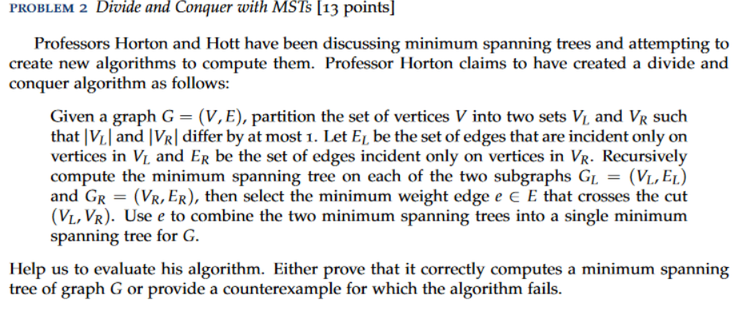

Answer:

We don’t always get an optimal solution with the divide and conquer method explained above.

Let’s take in consideration the following graph G, where Edge( B, C ) has cost 1 and (F, G) cost 2, and all others cost of 10.

A – B – C – D A – B C – D  
| | | | , after the first DAQ execution, we get the Graph like | | | |   
E – F – G – H E – F G – H

Then divide again, and get A – B C – D  
 | | , divide and conquer outputs this two as two MSTs. Let’s   
 E – F G – H connect them at (B, C) and we get a MST with cost of 61.

But, the actual minimum spanning tree would be with cost 51 A – B – C – D   
 |  
 E – F – G – H   
Hence, by the counterexample given, we might say that the Divide and Conquer algorithm was wrong.